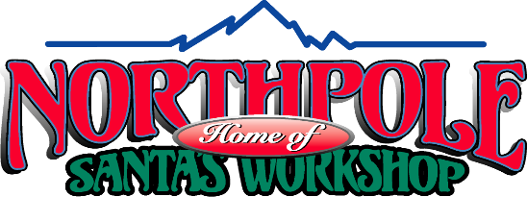

DRUG AND ALCOHOL POLICY

(1) No Drugs or Alcohol on the Job

Santa’s Workshop wants a healthy and safe workplace. To promote this goal, employees are required to report to work in appropriate mental and physical condition to perform their jobs in a satisfactory manner. In addition, Santa’s Workshop has responsibilities and obligations to its employees, customers and the public at large to ensure safety in our workplace and safety at Santa’s Workshop. Consequently, the following are strictly prohibited and may result in disciplinary action, up to and including immediate termination:

(a) reporting to work under the influence of intoxicating liquor, controlled substance or illegal drug;

(b) an employee’s use, possession, purchase or transfer on Santa’s Workshop’s premises or property (including storage in a desk, locker, car, etc.) or during work time of an intoxicating liquor, controlled substances, illegal drug, a drug not medically authorized, or any other substance which impairs job performance or poses a hazard to the safety and welfare of the employee, customers, the public or other employees; or

(c) the sale of any such item on Santa’s Workshop’s premises or during work time.

(2) Controlled Substances and illegal drugs

Marijuana is a “controlled substance” and “illegal drug” under federal law.

“Controlled substance” or “illegal drugs” can include prescription drugs. Employees may use prescription drugs so long as that use is consistent with a prescription and approved under working conditions by the employees’ doctor. Employees must promptly report to their supervisors their use of any prescription or non-prescription medication that may impair their judgment, alertness, performance or behavior.

(3) Searches

Santa’s Workshop may also require employees to consent to personal or facility searches when it has reason to suspect the presence of drugs or alcohol.

(4) Drug and Alcohol Screen Tests.

To help ensure a safe, healthy workplace, subject to applicable law, Santa’s Workshop may require the following screen tests for the presence of drugs and alcohol:

(a) Initial Drug and Alcohol Screen Tests. Santa’s Workshop requires all Outdoor Park Personnel applicants who have received conditional job offers to submit to drug and alcohol screen tests. Santa’s Workshop will not employ anyone who fails or refuses to take the screening test.

(b) Random, For Cause and Post-Accident Drug and Alcohol Screen Tests. Santa’s Workshop may require all current employees to submit to random, for cause and post-accident drug and alcohol screen tests. Random testing will be administered by the company performing the testing. “For cause” testing may be ordered for any employee whom Santa’s Workshop has reason to believe has violated Santa’s Workshop’s policies against drugs and alcohol at work and requiring employees to be sober and drug-free on the job. Santa’s Workshop may also order any employee(s) involved in an accident on the job to be tested, whether or not the employee(s) caused the accident and/or were injured.

All applicants and employees who are tested for drugs or alcohol must provide body substance samples (such as breath, urine and/or blood) to determine the use of alcohol or illegal drugs. Santa’s Workshop will pay for any drug and alcohol screen test and the reasonable cost of transportation to and from the testing facility.

(5) Violation of this Policy

Subject to applicable law, violation of these policies, refusal to be tested or refusal to cooperate with these procedures, or positive test results for tested substances may result in discipline up to and including immediate termination. Santa’s Workshop reserves the right to change this policy at any time in its sole discretion.

The undersigned employee acknowledges the receipt and understanding of Santa’s Workshop’s Drug and Alcohol Policy.

Employee Name (please print):

Signature:

Date:

